**Message Communication:**

**Assignment Description**

Create an application where you can log on, check messages other users have sent to you, and send messages to other users.

1.Technologies used:

* Spring Boot
* Java 8
* Maven
* WebSocket’s
* MySQL
* HTML

2.Overview of Assignment:

* Using WebSocket’s and Stomp Concept developed the application.
* Storing the user and Messages Information to the Database.
* Boot the application in browsers and start communicating the other users.
* List the User message history with the username, messages and Date.

3.Schema Create and insert Queries: 

**WEBSCOKET:**

**WebSocket** is a communication protocol, which helps establish a two-way communication channel between client and server.

**WebSocket**is not a  **request-response** protocol, where only Clientcan send a request to the Server. When a connection with **WebSocket** protocol is established, **client & server** can give data to each other, until the lower layer connection such as **TCP** is closed. The WebSocket is basically similar to the TCP **Socket** concept. The difference is that the WebSocket is created to use for Webapplications.

**STOMP:**

STOMP (Streaming Text Oriented Messaging Protocol): a communication protocol, a branch of the WebSocket. When the client and the server contact each other by this protocol, they will send each other text message data. The relationship between STOMP and WebSocket is also similar to the one between HTTP and TCP.

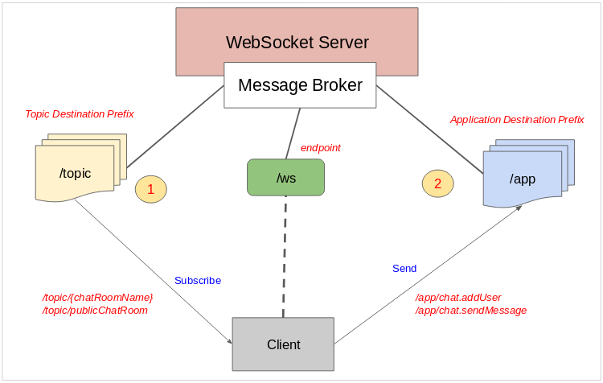

ScreenShots:

1. Enter First User : <http://localhost:7777/>login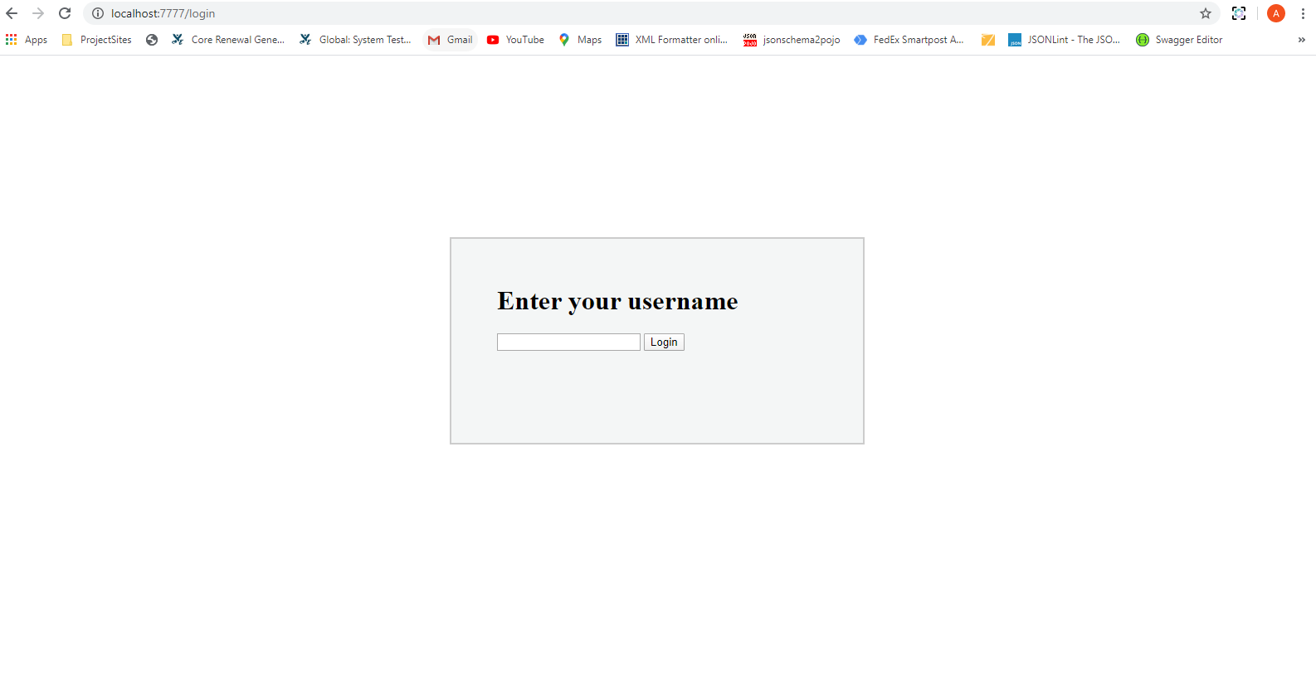

2. Enter Second User: <http://localhost:7777/>

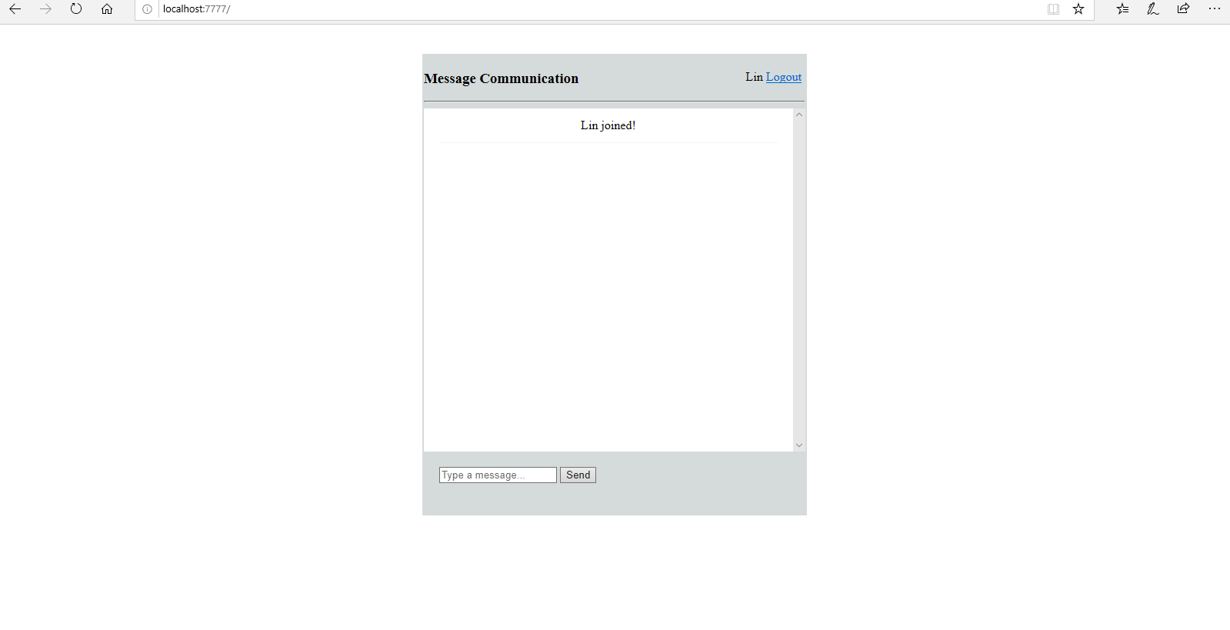

3. Conversation between 2 Users in one user window

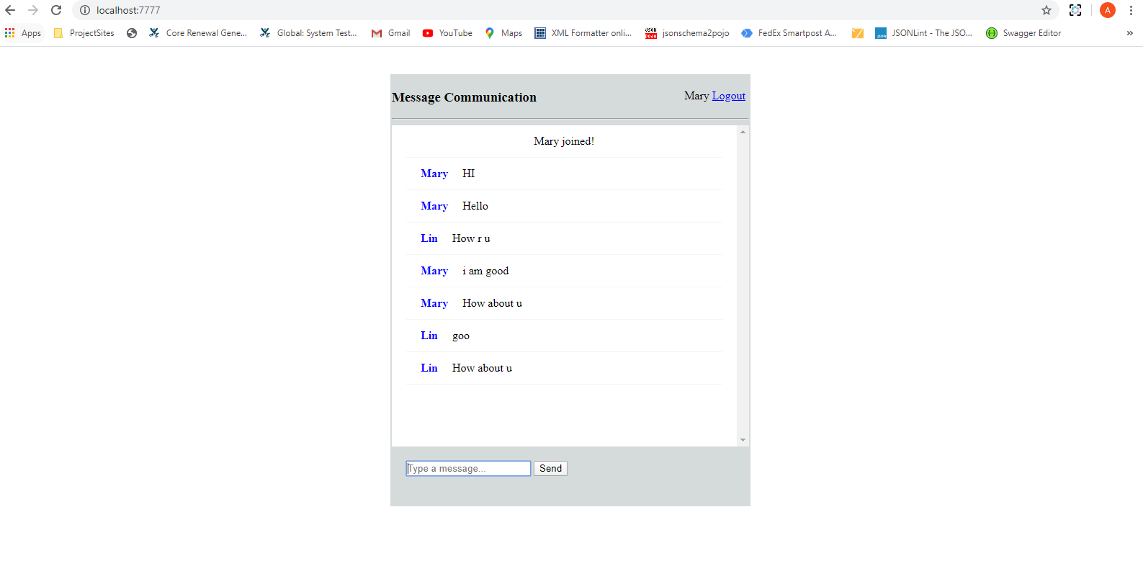

4.Conversation between two Users in another user window

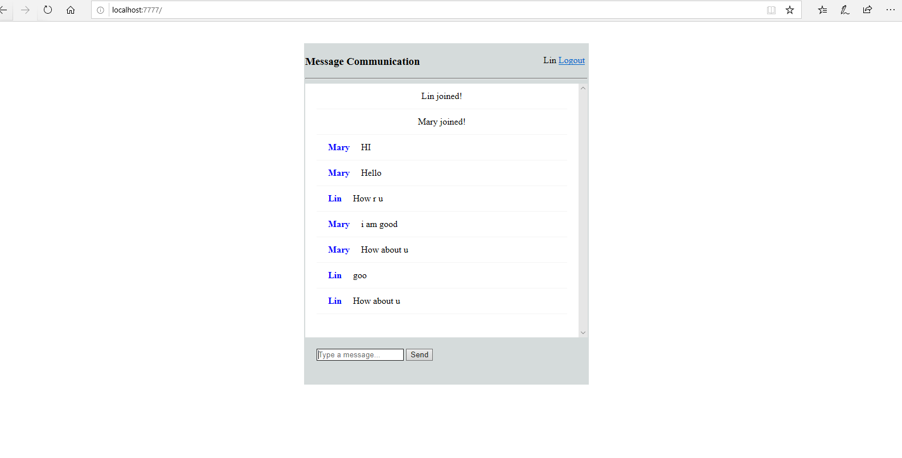

5.Communication History between two users : <http://localhost:7777/list>- 